Creating Cluster Using EMR

Here are steps given below for creating new cluster using EMR.

1. Search EMR on find services.

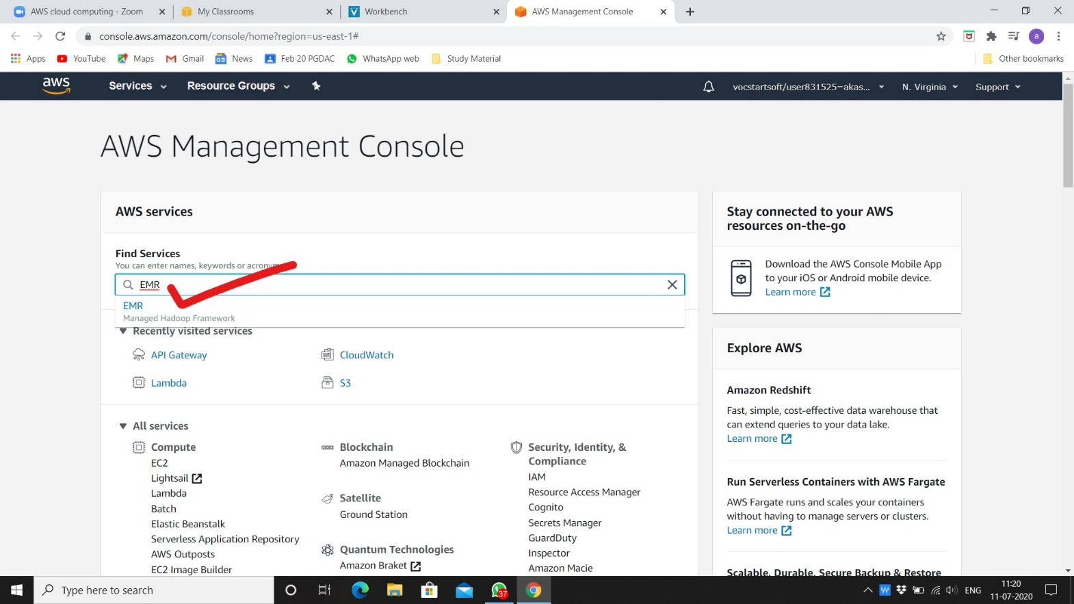

1. You will see welcome page, click on create cluster.

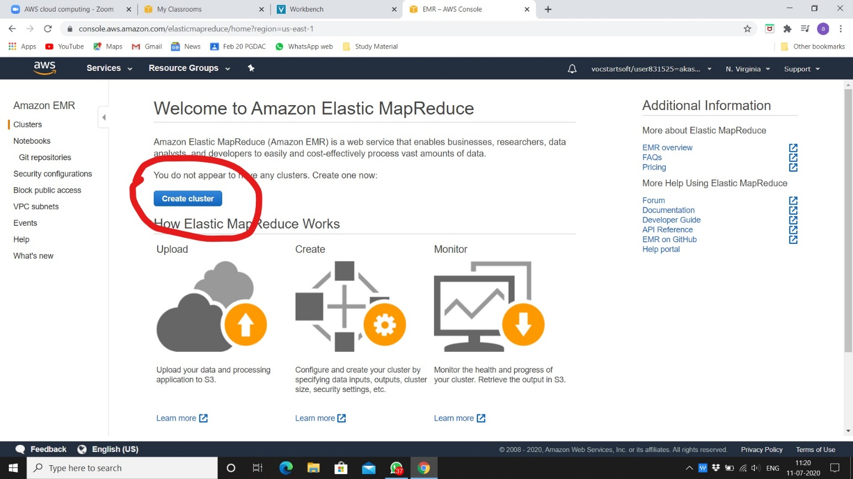

1. Fill given options like below image for basic cluster. You can change software configuration as per your requirements.

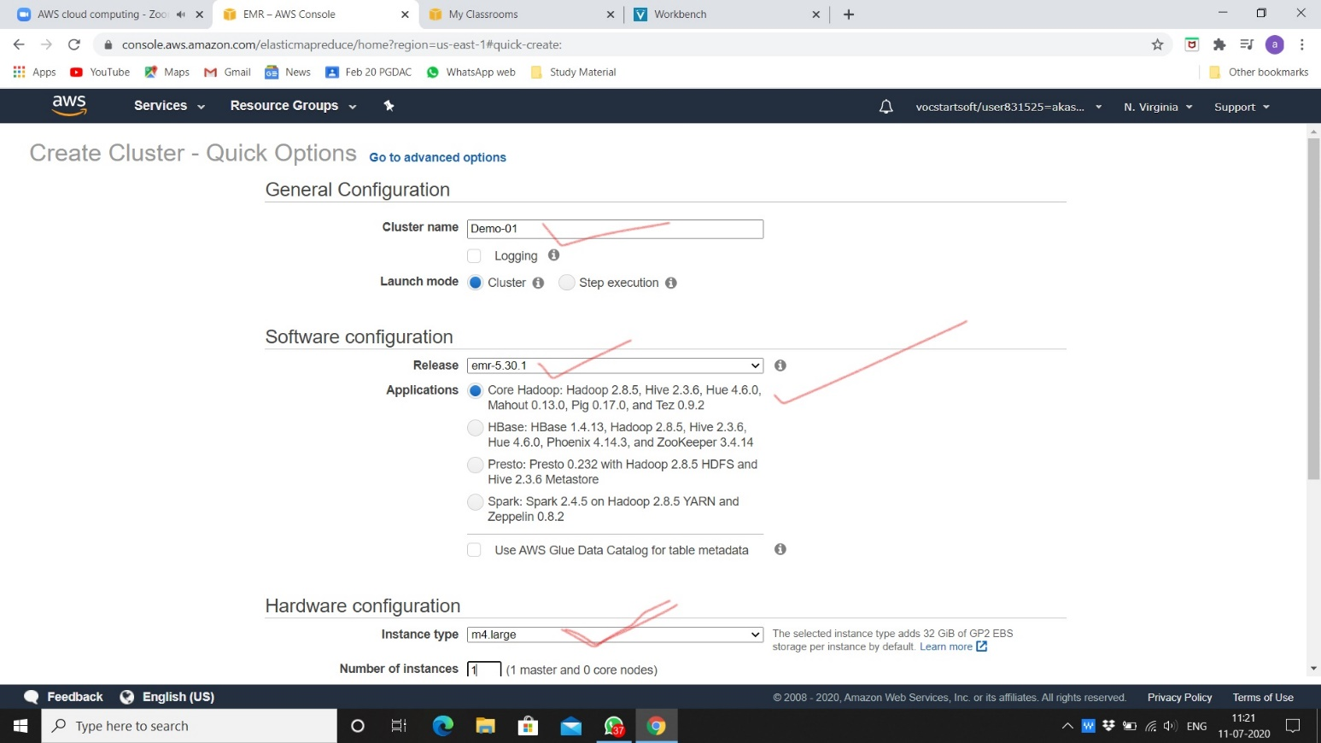

1. Give EC2 key pair as created previous.

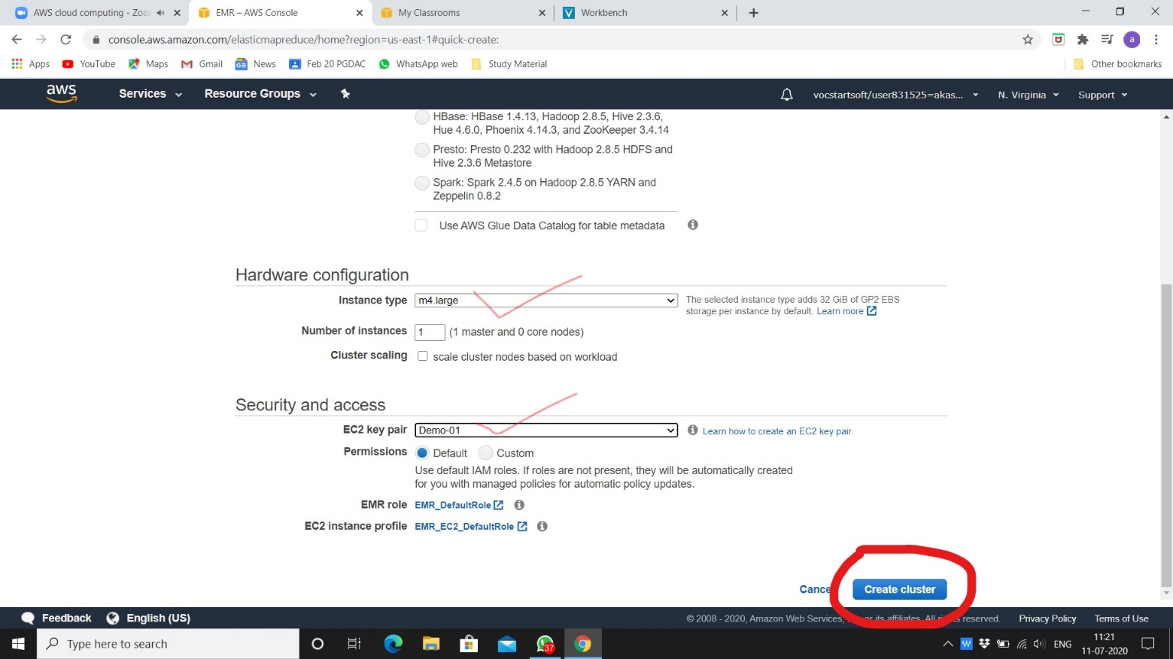

1. After creating you will see this page and wait for changing state starting to waiting to use cluster.

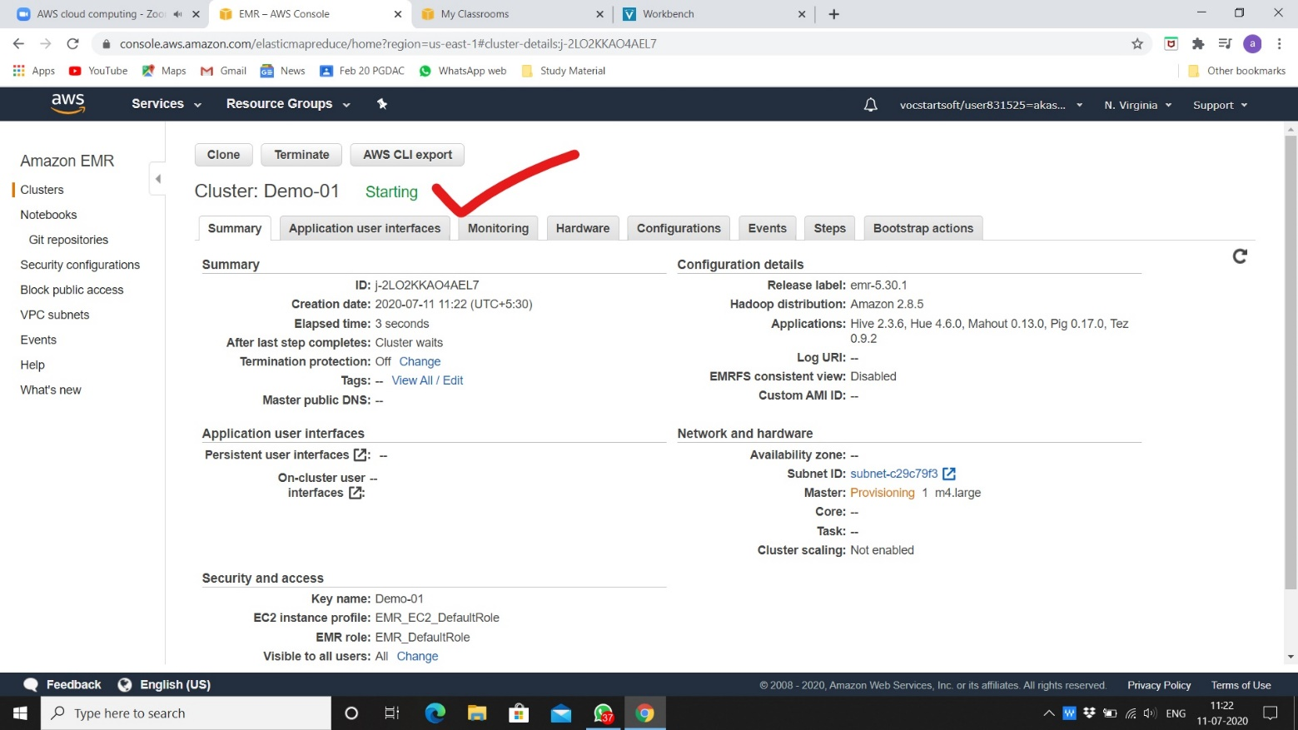

1. We can use cluster now on MobaXterm.

